PROJECT DOCUMENTATION

EXPLORATORY DATA ANALYSIS USING PYTHON
AND MACHINE LEARNING

Title: IPL Match Records

Name: Gunaseelan.C

Course: DA/DS, Offline

Batch: June 2025

TABLE OF CONTENT
1. | Introduction
2. | Aim
3. | Problem Statements
4. | Project Workflow
5. | Data Understanding
6. | Data Cleaning
7. | Exploratory Data Analysis (EDA) - Univariate Analysis
8. | Bivariate Analysis
9. | Multivariate Analysis
10. | Overall Insights from Analysis
11. | Conclusion

1.Introduction
The Indian Premier League (IPL) is one of the most exciting and popular cricket tournaments in the world. It brings together top players from different countries and creates a fast-paced, high-scoring format that attracts millions of fans each year.
This project focuses on analyzing IPL match records to understand different patterns and trends in the data. By studying past match information such as teams, venues, toss results, winners, and player performances, we can gain useful insights about what factors influence the outcome of matches.
Data analysis helps us explore team strengths, key players, venue advantages, and seasonal changes in performance. These insights can be useful for teams, analysts, and cricket fans to better understand the game.

2.Aim
The main aim of this project is to analyze IPL match data to find meaningful patterns and insights.
Through data cleaning and exploratory data analysis, we aim to:
- Understand the performance of different teams and players.
- Identify factors that influence match outcomes, such as toss decisions and venues.
- Explore seasonal trends and winning patterns.
- Gain insights that can help in making better predictions and understanding the game more deeply.

3.Problem Statements
The IPL dataset contains a large amount of information about matches, teams, players, and venues. However, without proper analysis, it is difficult to understand the hidden patterns and factors that affect match outcomes.
There is a need to:
- Identify key factors that influence winning and performance.
- Understand team and player trends over different seasons.
- Analyze how toss decisions and venues impact match results.
- Organize and clean the data to make it suitable for meaningful analysis.
By solving these problems, we can gain valuable insights from the IPL data.

4.PROJECT WORKFLOW
- Introduction
  - Notebook starts with a markdown header: "IPL Dataset".
- Library Setup
  - Imports required libraries: pandas, numpy, matplotlib, seaborn, warnings.
- Data Loading
  - Reads the dataset from ipl_matches.csv.
  - Displays the dataset (df, head(), tail()).
- Initial Data Exploration
  - Checks dataset info (info(), shape, columns).
  - Inspects null values and data types.
  - Describes numerical features (describe()).
- Data Cleaning & Preprocessing
  - Handles missing values.
  - Drops/renames irrelevant columns (if any).
  - Encodes categorical columns (like teams, venues, etc.).
- Exploratory Data Analysis (EDA)
  - Visualizations using matplotlib and seaborn:
    - Matches per Season.
    - Top 10 Cities by Matches Hosted.
    - Winner vs Toss Decision.
    - Team Wins Across Seasons.
    - Multivariate Scatter Plot: Match Outcomes.
- Advanced Analysis
  - Player performance (e.g., top batsmen, bowlers).
  - Team performance trends across seasons.
  - Toss vs. match outcome correlation.
- Visual Insights
  - Heatmaps, bar plots, and line charts for comparative insights.
  - Correlation matrix for numerical features.
- Summary & Conclusions
  - Key findings from IPL data trends.
  - Insights on teams, players, and match outcomes.

5.Data Understanding
Dataset Size
- Typically includes thousands of rows (each row = one match or delivery, depending on dataset version).
- Columns describe match details (teams, players, venue, outcomes).
Common Columns
- id: Match ID (unique identifier).
- season: IPL season/year.
- city: City where the match was played.
- date: Match date.
- team1, team2: Competing teams.
- toss_winner: Team winning the toss.
- toss_decision: Bat or field decision.
- result: Type of result (win, tie, no result).
- winner: Winning team.
- win_by_runs, win_by_wickets: Margin of victory.
- player_of_match: Best performer.
- venue: Stadium/ground.
- umpire1, umpire2: Match officials.
Data Types
- season, win_by_runs, win_by_wickets: Numeric (integer).
- date: Date/time.
- teams, venue, winner, player_of_match: Categorical (string).
Key Insights Possible
- Which teams/players dominate across seasons.
- Toss impact on match outcomes.
- Venue-specific performance trends.
- Winning patterns (by runs vs. by wickets).

6. Data Cleaning
Remove Duplicates
- Drop duplicate rows if any:
- df.drop_duplicates(inplace=True)
Handle Missing Values
- Check null values:
- df.isnull().sum()
- Fill/drop depending on column:
  - umpire1, umpire2: If missing, can be filled with "Unknown".
  - winner: If missing → mark as "No Result".
  - player_of_match: If missing → "NA".
  - Drop columns with too many missing values (e.g., umpire3 in some datasets).
Standardize Team Names
- Old teams sometimes appear with different spellings (e.g., "Delhi Daredevils" vs. "Delhi Capitals").
- Use a dictionary to map:
- team_map = {
- "Delhi Daredevils": "Delhi Capitals",
- "Deccan Chargers": "Sunrisers Hyderabad",
- # add more if needed
- }
- df['team1'] = df['team1'].replace(team_map)
- df['team2'] = df['team2'].replace(team_map)
- df['winner'] = df['winner'].replace(team_map)
- df['toss_winner'] = df['toss_winner'].replace(team_map)
Convert Data Types
- Convert date column to datetime:
- df['date'] = pd.to_datetime(df['date'])
- Ensure numerical columns (win_by_runs, win_by_wickets, season) are integers.
Feature Engineering (Optional)
- Create new features for analysis:
  - win_type: "Runs" if win_by_runs > 0, "Wickets" if win_by_wickets > 0.
  - is_home_team: whether the winner played in home city.
  - match_decision: combine toss + match outcome.
Drop Irrelevant Columns
- Columns like id (if not needed), or extra umpire columns with mostly nulls.

7.EXPLORATORY DATA ANALYSIS (EDA)
UNIVARIATE ANALYSIS
Univariate analysis focuses on exploring individual variables to understand their distribution, patterns, and anomalies.

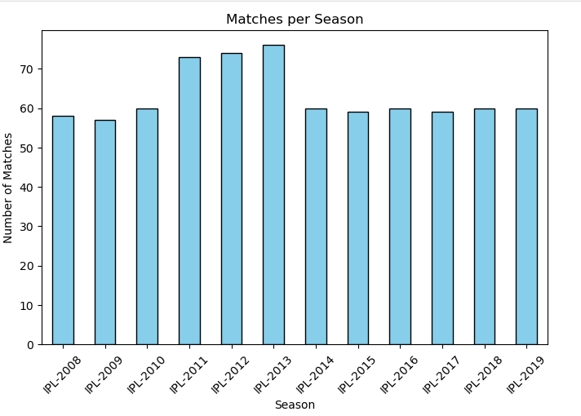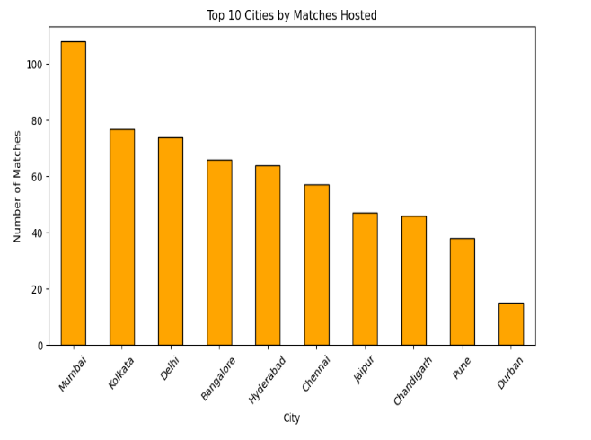

Insights Gained:
- The number of matches increased steadily from IPL 2008 to IPL 2013, peaking in 2013 (~76 matches).
- From 2014 onwards, the matches stabilized around 59–60 per season, showing a more balanced schedule.
- The early growth reflects tournament expansion, while the later stabilization indicates the league settled into a standard format.
- Mumbai leads with 100+ matches (major venues).
- Kolkata, Delhi, Bangalore, Hyderabad, Chennai: 60–80 matches each (key home grounds).
- Jaipur, Chandigarh, Pune: 40–50 matches (secondary venues).
- Durban: ~15 matches (2009 IPL in South Africa).

8. BIVARIATE ANALYSIS
Bivariate analysis helps explore relationships between two variables, uncovering trends, correlations, and dependencies that impact housing prices

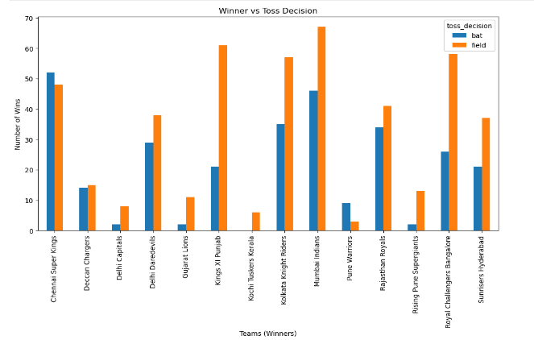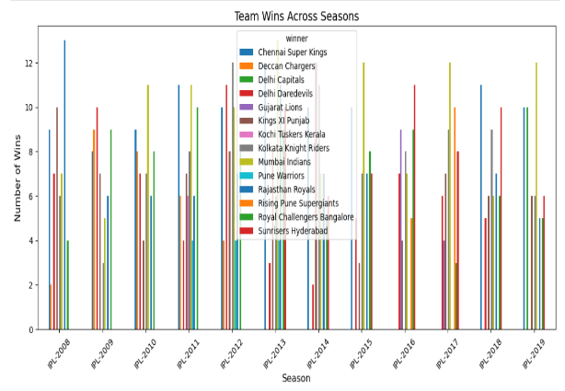

Insights Gained:
- Most teams win more often when they choose to field first (chasing).
- A few strong teams (like CSK, MI) win in both batting and fielding, but chasing still has the edge
- Smaller teams don’t show clear patterns because they had fewer matches.
- CSK and MI win the most matches across many seasons.
- Other teams like KKR, SRH, RR have strong individual seasons.
- Short-lived teams (like Deccan Chargers, Gujarat Lions, Kochi Tuskers) appear only for a few years.
- Overall, the chart shows which team dominated each season.

9. MULTIVARAIATE ANALYSIS
Insights:
    - Teams high on the Y-axis are frequent winners.
    - Points far right are dominant wins.
    - Color shows result type.
    - Horizontal spread shows consistency in performance.
    - Batting first → higher average win margins by runs (teams win by defending totals).
    - Fielding first → low/near-zero margins (since chasing teams usually win by wickets, not runs).
    - Team differences: Some teams show very high values in bat (strong at defending), while others stay low (win more by wickets).
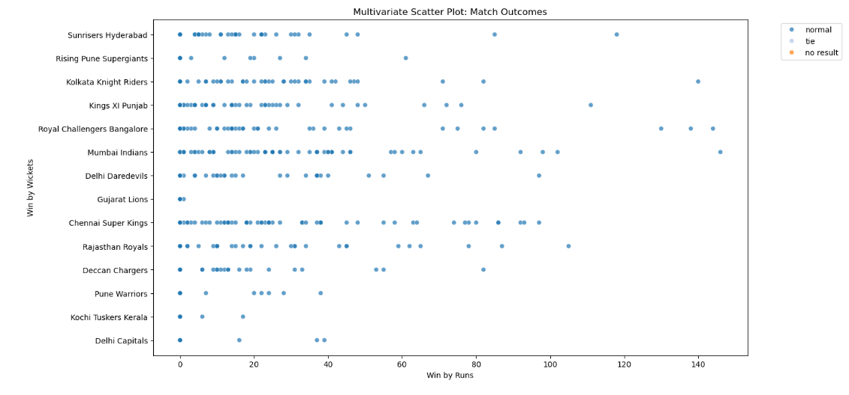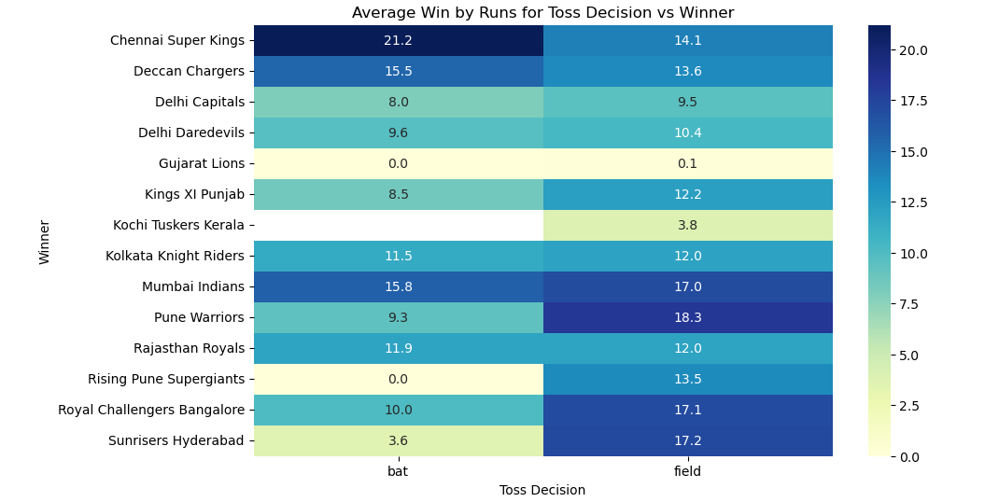

10.OVERALL INSIGHTS FROM ANALYSIS
1.Univariate Analysis
- The number of matches increased steadily from IPL 2008 to IPL 2013, peaking in 2013 (~76 matches).
- From 2014 onwards, the matches stabilized around 59–60 per season, showing a more balanced schedule.
- The early growth reflects tournament expansion, while the later stabilization indicates the league settled into a standard format.
- Mumbai leads with 100+ matches (major venues).
- Kolkata, Delhi, Bangalore, Hyderabad, Chennai: 60–80 matches each (key home grounds).
- Jaipur, Chandigarh, Pune: 40–50 matches (secondary venues).
- Durban: ~15 matches (2009 IPL in South Africa).

2. Bivariate Analysis
- Most teams win more often when they choose to field first (chasing).
- A few strong teams (like CSK, MI) win in both batting and fielding, but chasing still has the edge
- Smaller teams don’t show clear patterns because they had fewer matches.
- CSK and MI win the most matches across many seasons.
- Other teams like KKR, SRH, RR have strong individual seasons.
- Short-lived teams (like Deccan Chargers, Gujarat Lions, Kochi Tuskers) appear only for a few years.
- Overall, the chart shows which team dominated each season.
3. Multivariate Analysis
    - Teams high on the Y-axis are frequent winners.
    - Points far right are dominant wins.
    - Color shows result type.
    - Horizontal spread shows consistency in performance.
    - Batting first → higher average win margins by runs (teams win by defending totals).
    - Fielding first → low/near-zero margins (since chasing teams usually win by wickets, not runs).
    - Team differences: Some teams show very high values in bat (strong at defending), while others stay low (win more by wickets).

11. Conclusion
This project shows how IPL match data can be analyzed to find meaningful patterns. By using data cleaning and EDA techniques, we can understand team performance, player contributions, and other key factors. This type of analysis can help teams, fans, and analysts make better decisions and predictions. In the future, this project can be extended with machine learning to predict match winners or player performance.

